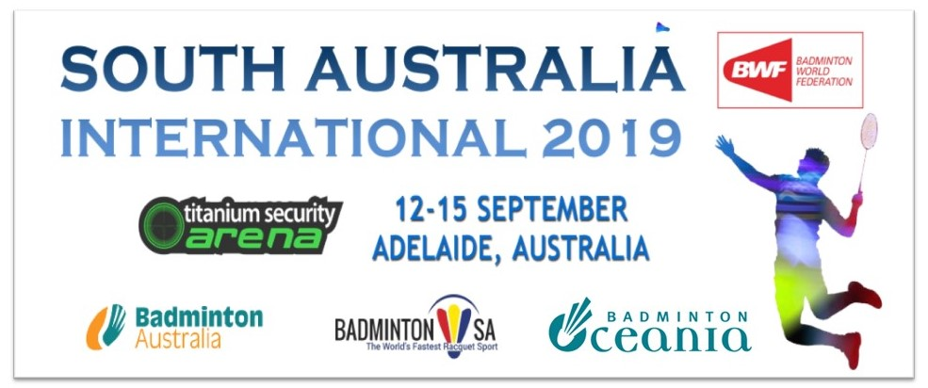

PRACTICE REQUEST FORM

MEMBER ASSOCIATION (Country):

DATE | NUMBER OF PLAYERS | START TIME | FINISH TIME

Notes:
1. There are 5 main competition courts and 2 practice courts.
2. Based on information provided above by all participants, event organiser will arrange a fair
practice session times on the main competition and practice courts as requested.

Please return this form by 28th August 2019 to:
Mr Simon Oaten
Email: oatense@gmail.com
Telephone: +61 434624810

