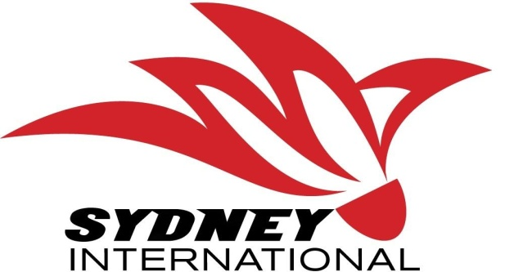
Sydney International 2022

Sydney, AUSTRALIA 05 – 09 October, 2022
VISA REQUEST FORM
MEMBER ASSOCIATION (Country) |  | CONTACT NAME (In Full):)
CONTACT phone number |  | CONTACT email address:

No . | FAMILY NAME (on passport) | GIVEN NAMES (on passport) | GENDER | NATIONALITY | PASSPORT NUMBER | EXPIRY DATE | DATE OF BIRTH | ROLE (player, coach, etc)
1.
2.
3.
4.
5.
6.
7.
8.
9.
10.
Notes:
- Member associations requiring visa to enter Australia please complete the above form and return to Badminton NSW Email: ctohy@yahoo.com.au Tel: +61 419 225 008.
- We will forward an official invitation letter for your visa application to your contact email address the next business day after receipt.
- Please allow sufficient time for your visa application. We recommend applying at least 30 days prior to your planned travel dates.

