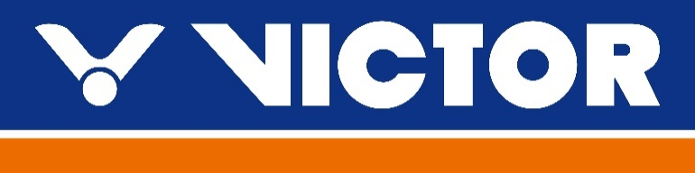
VICTOR North Harbour International 2022
Auckland, New Zealand
20-23 March
TRANSPORT REQUEST FORM
MEMBER ASSOCIATION Country:

GROUP 1 | ARRIVAL | DEPARTURE (indicate if traveling to Waikato)
DAY/DATE/TIME:
FLIGHT NUMBER:
TOTAL NO: OF PERSONS:
RAMADA HOTEL:
GROUP LEADER (NAME & MOBILE)

GROUP 2 | ARRIVAL | DEPARTURE (indicate if traveling to Waikato)
DAY/DATE/TIME:
FLIGHT NUMBER:
TOTAL NO: OF PERSONS:
RAMADA HOTEL:
GROUP LEADER (NAME & MOBILE)

Notes:
- Transport pick up is for arrivals & departures at Auckland International Airport.
- Transport is provided for participants staying at the official hotel only (Ramada).
- Please notify organiser if details have changed prior to arrival.
Please return this form by 5 October 2022 to:
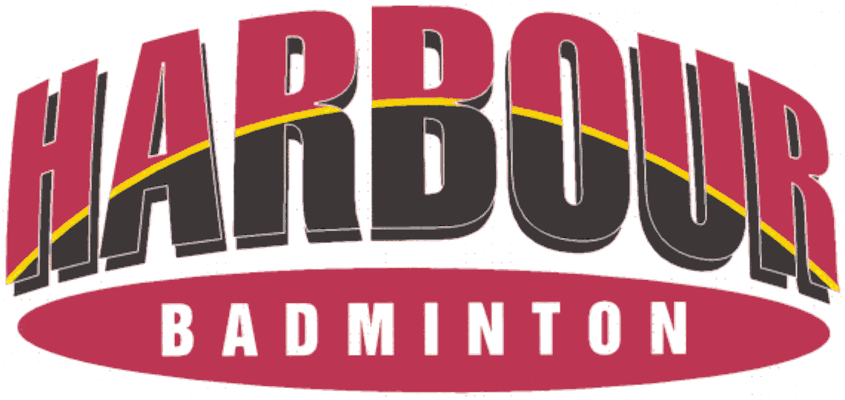
Event Director Email: lisa@bnh.org.nz Telephone: +64 21477 794

