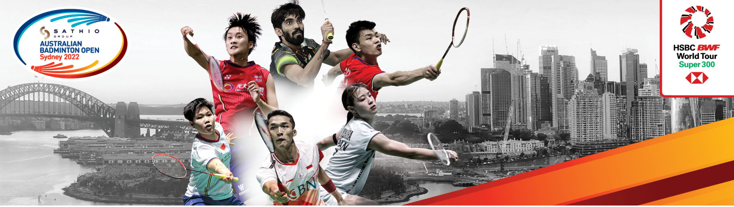

SATHIO GROUP AUSTRALIA OPEN 2022
SYDNEY AUSTRALIA 15-20 NOVEMBER

ACCREDITATION FORM

MEMBER ASSOCIATION Country: |  | CONTACT NAME In full:
CONTACT Phone number: |  | CONTACT Email address:

No. | Mr/Ms | NAME | PLAYER/COACH/OFFICIAL  MEDIA/BWF
1.
2.
3.
4.
5.
6.
7.
8.
9.
10.

Notes:
1. Please provide head shot photo of everyone listed above.
2. Please refer to prospectus for complimentary passes for team officials.
3. Additional passes for team officials can be purchased for AUD$150 each.

Please return this form by Tuesday 18th Oct 2022 to:
Ms Kathy Fong
Email: austopen2022@gmail.com
Telephone: +61 404 613 456
