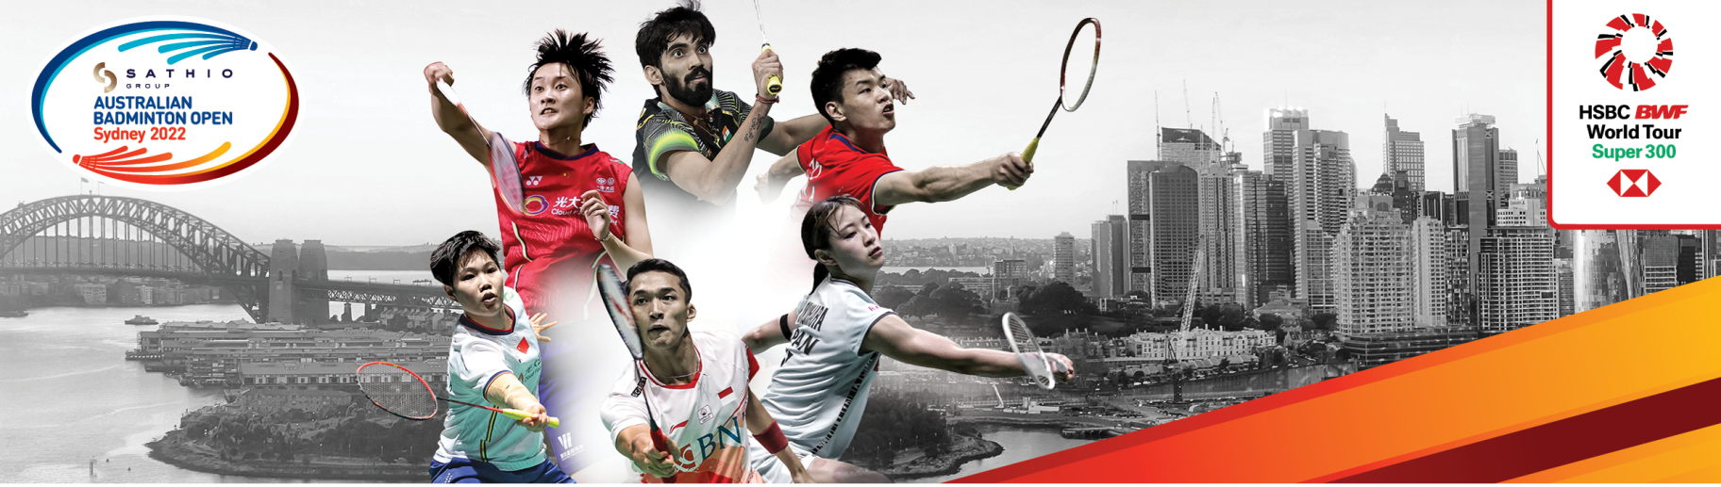

SATHIO GROUP AUSTRALIA OPEN 2022
SYDNEY AUSTRALIA 15-20 NOVEMBER

VISA REQUEST FORM

MEMBER ASSOCIATION Country: |  | CONTACT NAME In full:
CONTACT Phone number: |  | CONTACT Email address:

No. | FAMILY NAME  (on passport) | GIVEN NAMES  (on passport) | GENDER | NATIONALITY | PASSPORT  NUMBER | EXPIRY  DATE | DATE  OF  BIRTH | ROLE  (player, coach, etc)
1.
2.
3.
4.
5.
6.
7.
8.
9.
10.

Notes:
1. Member associations requiring visa to enter Australia please complete the above form.
2. We will forward an official invitation letter for your visa application.

Please return this form by Tuesday 4th Oct 2022 to:
Ms Kathy Fong
Email: austopen2022@gmail.com
Telephone: +61 404 613 456
