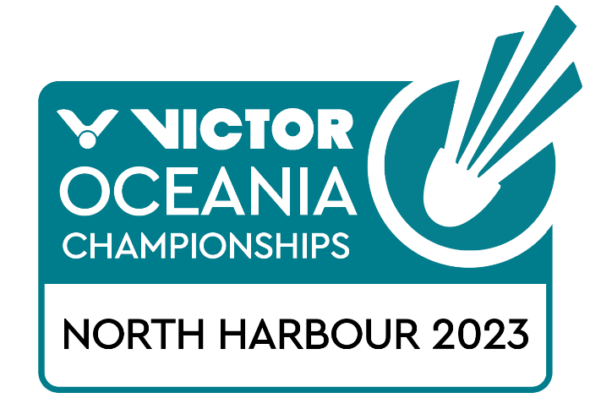
Junior Mixed Team Championships (10-12 February)
Junior and Open Individual Championships (13-16 February)
Open Mixed Team Championships (17-19 February)

North Harbour, New Zealand
TRANSPORT REQUEST FORM

MEMBER ASSOCIATION Country:

Group 1 | ARRIVAL | DEPARTURE
DAY/DATE/TIME:
FLIGHT NUMBER:
TOTAL NO: OF PERSONS:
GROUP LEADER (NAME & MOBILE)

GROUP 2 | ARRIVAL | DEPARTURE
DAY/DATE/TIME:
FLIGHT NUMBER:
TOTAL NO: OF PERSONS:
GROUP LEADER (NAME & MOBILE)

Notes:
- Transport pick up is for arrivals & departures at Auckland International Airport.
- Transport is provided for participants staying at the official accommodation venues only
- Please notify Badminton Oceania if details change prior to arrival
Please return this form by 31 January 2023 to:
Email: events@badmintonoceania.org

