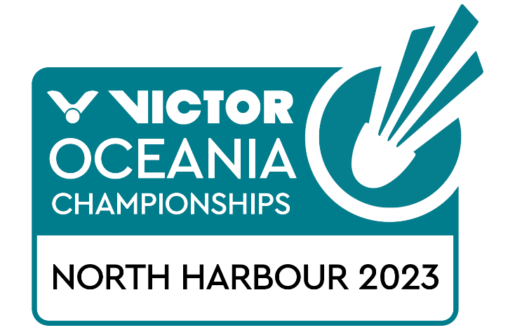

Junior Mixed Team Championships (10-12 February)
Junior and Open Individual Championships (13-16 February)
Open Mixed Team Championships (17-19 February)

North Harbour, New Zealand
VISA REQUEST FORM

MEMBER ASSOCIATION Country: |  | CONTACT NAME in full:
CONTACT phone number: |  | CONTACT email address:

NO | FAMILY NAME (on passport) | GIVEN NAMES (on passport) | GENDER | NATIONALITY | PASSPORT NUMBER | EXPIRY DATE | DATE OF BIRTH | ROLE (player, coach, etc)
1
2
3
4
5
6
7
8
9
10

Notes:
- Member associations requiring a Visa to enter New Zealand please complete the above form and return to Badminton Oceania – events@badmintonoceania.org
- We will forward the official invitation letter for your visa application to your contact email address the next business day after receipt.
- Please allow sufficient time for you visa application. We recommend applying as far in advance as possible as processing times are currently slow.

