SAIPAN INTERNATIONAL 2023
SAIPAN, NORTHERN MARIANA ISLANDS
JUNE 13-18, 2023

VISA REQUEST FORM

MEMBER ASSOCIATION Country: |  | CONTACT NAME In full:
CONTACT Phone number: |  | CONTACT Email address:

NO | FAMILY  NAME  (passport) | GIVEN  NAMES  (passport) | GENDER | NATIONALITY | PASSPORT NUMBER | EXPIRY DATE | DATE OF BIRTH | ROLE (player, coach, etc)
1
2
3
4
5
6
7
8
9
10

Notes:
- Players and officials requiring a Visa to enter the NMI must complete the above form and return to Event Director as soon as possible. To see list of countries under the United States and NMI Visa Waiver Program and would only need Electronic System for Travel Authorization (ESTA), visit https://www.dhs.gov/visa-waiver-program-requirements or https://esta-center.com/en/guam/index.html for more information. To apply for ESTA or United States visa, please see Page 3 of this form.

- Official invitation letter for your Visa application will be sent to your contact address.

- Please allow sufficient time for the processing of your application. We recommend applying at least 45 days prior to your planned travel dates.

Please return this form to:
Event Director
Email: roselynmonroyo@gmail.com Telephone: 1-670-789-1845

ESTA APPLICATION PROCESS

- Go to this link https://esta.cbp.dhs.gov/
- Click New Application
- Fill out application
- Submit
- Pay Fees

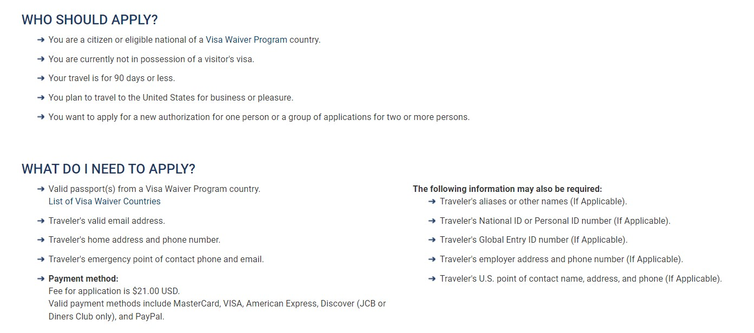

U.S. VISA APPLICATION PROCESS

- Players and officials whose country are not under the visa waiver program, visit https://travel.state.gov/content/travel/en/us-visas.html to apply for United States visa.

- Choose Non-Immigrant Visa, B-1.

- Fill out form and submit requirements.

- Set up appointment for interview and pay fee. You may be required to appear at the U.S. Embassy or Consulate at your country of origin for interview with the consular officer. For more information, check https://travel.state.gov/content/travel/en/us-visas/tourism-visit/visitor.html

