YONEX Bendigo International 2023
BENDIGO, VICTORIA, AUSTRALIA
11 – 15 October 2023

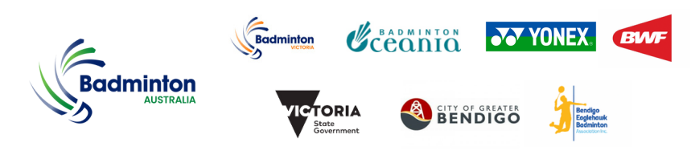
PRACTICE REQUEST FORM
Member Association Country:  Contact Phone Number:  Contact Name (full):  Contact Email address: | INSERT  INSERT  INSERT  INSERT
Booking Details | Practice courts are located at:  Bendigo-Eaglehawk Badminton Association  140 Victoria Street, Eaglehawk  Courts are available Mon 9th – Fri 13th Oct from 9:00am – 5:00pm daily.  Bookings outside these times will be on pay per use basis.  DATE NUMBER OF PLAYERS PREFERRED TIME (between 9am-5pm)  Mon 9th Oct 2023  Tue 10th Oct 2023  Wed 11th Oct 2023  The organiser will allocated the courts based on the number of players and courts availability for the times requested.  Practice requests confirmation for Thu & Fri will be notified at the venue upon approval by the Referee.  Practice requests for Sat & Sun will be on pay per use basis.
Notes | For practice at the Competition Venue, the organiser will allocate the courts/times on a fair and equitable basis for Tuesday 10th October from 4:00pm – 10:00pm.  Please complete and return this form by Friday 29th September 2023 to:  Name: Anthony Pinda  Email: anthony.pinda@badminton.org.au

