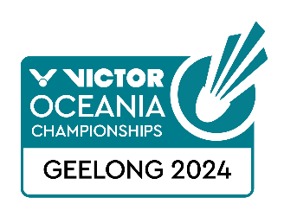
VICTOR Oceania Championships 2024
TRANSPORT REQUEST FORM

Member Association Country  Contact Phone number  Contact name (full)  Contact email address | Type Here  Type Here  Type Here  Type Here  Type Here
Group 1 | GROUP 1 ARRIVAL DETAILS DEPARTURE DETAILS  DAY/DATE/TIME:  FLIGHT NUMBER:  TOTAL NO: OF PERSONS:  GROUP LEADER (NAME & MOBILE)
Group 2 | GROUP 2 ARRIVAL DEPARTURE  DAY/DATE/TIME:  FLIGHT NUMBER:  TOTAL NO: OF PERSONS:  GROUP LEADER (NAME & MOBILE)
Notes | - Transport is for arrivals & departures at Melbourne Tullamarine and Avalon International Airports.  - Transport is provided for participants staying at the official accommodation venue only – Best Western Geelong Motor Inn & Serviced Apartments  - Please notify Badminton Oceania if details change prior to arrival.  - Airport arrival transfers will only be provided on Sunday 11th February.  - Airport departure transfers will only be provided on Thursday 15th or Friday 16th February and following the complete of the Men’s & Women’s Team Championships for players in teams  - Please attach booking confirmations from the Best Western Geelong Motor Inn & Serviced Apartments when submitting this form
Return Form | Please return this form by 1 February 2024 to:  Badminton Oceania  events@badmintonoceania.org

