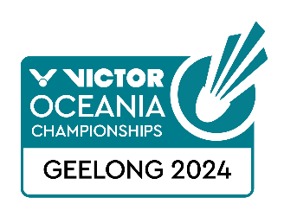
VICTOR Oceania Championships 2024
VISA REQUEST FORM

Member Association Country:  Contact Phone Number:  Contact Name (full):  Contact Email address: | Type Here  Type Here  Type Here  Type Here
Notes | - Member associations requiring a Visa to enter Australia please complete the above form and return to Badminton Oceania email: events@badmintonoceania.org  - We will forward the official invitation letter for your visa application to your contact email address the next business day after receipt  - Please allow sufficient time for you visa application. We recommend applying at least 30 days prior to your planned travel dates
Return Form | Please return this form by 15 December 2023 to:  Badminton Oceania  events@badmintonoceania.org

NO | FAMILY NAME (on passport) | GIVEN NAMES (on passport) | GENDER | NATIONALITY | PASSPORT NUMBER | EXPIRY DATE | DATE OF BIRTH | ROLE (player, coach, etc)
1
2
3
4
5
6
7
8
9
10

