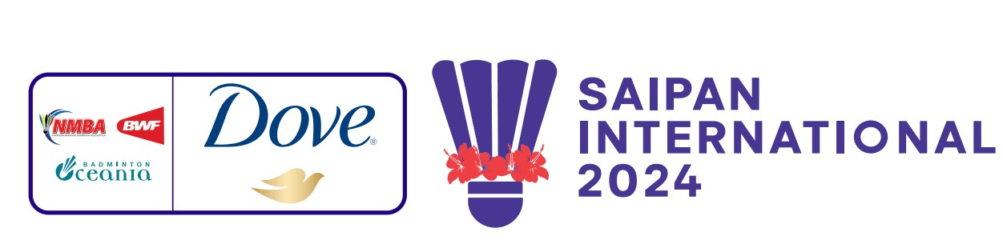
JULY 9-13, 2024

PRACTICE REQUEST FORM

MEMBER ASSOCIATION Country: |  | CONTACT NAME In full:
CONTACT NUMBER |  | CONTACT Email address:

DATE | NUMBER OF PLAYERS | Practice Courts (6) |  | Competition Courts (4)
 |  | Available  Time | Request  Time | Available  Time | Request Time
Sun 7 July |  | 9am – 5pm |  | Not Available
Mon 8 July |  | 9am – 5pm |  | 9am-5pm
Tue 9 July |  | 9am – 5pm |  | Not Available
Wed 10 July |  | 9am – 5pm | To book on Tuesday | Not Available
Thu 11 July |  | 9am – 5pm | To book on Wednesday | Not Available
Fri 12 July |  | 9am – 5pm | To book on Thursday | Not Available
Sat 13 July |  | 9am – 5pm | To book on Friday | Not Available

Notes:
1. There are three (3) competition courts and one (1) warm up courts at the Gilbert C. Ada Gymnasium.
2. There are six (6) practice courts at the Marianas High School Gymnasium.
3. Courts are available
3. Based on information provided above by all participants, the event organiser will arrange
a fair practice session times for all competitors.
4. Courts will be available for practice starting on Sunday July 7th .

Please return this form by 5 July 2024 for bookings on Sunday, Monday and Tuesday to:
Event Director
Email: roselynmonroyo@gmail.com Telephone: 1-670-789-1845

