YONEX Bendigo International 2024
BENDIGO, VICTORIA, AUSTRALIA
09 – 13 October 2024

TRANSPORT REQUEST FORM
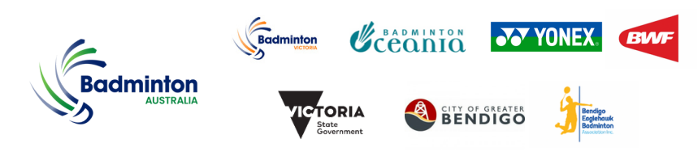
Member Association Country  Contact Phone number  Contact name (full)  Contact email address | INSERT  INSERT  INSERT  INSERT
Group 1 | GROUP 1 ARRIVAL DETAILS DEPARTURE DETAILS  DAY/DATE/TIME:  FLIGHT NUMBER:  TOTAL NO. OF PERSONS:  HOTEL:  GROUP LEADER (NAME & MOBILE)
Group 2 | GROUP 2 ARRIVAL DEPARTURE  DAY/DATE/TIME:  FLIGHT NUMBER:  TOTAL NO. OF PERSONS:  HOTEL:  GROUP LEADER (NAME & MOBILE)
Notes | - Transport pick up is only available from Sun 6th Oct to Tue 8th Oct 2024.  - Transport pick up is for arrivals & departures at Melbourne Tullamarine Airport only.  - Transport is provided for participants staying at the official hotels only.  - Please notify organiser if above flight details have changed prior to arrival.
Please complete and return this form by Friday 27th September 2024 to:
Name: Anthony Pinda
Email: anthony.pinda@badminton.org.au

Request for airport pick up after the 27th September 2024 may not meet the transport planning timeline and may be rejected.

