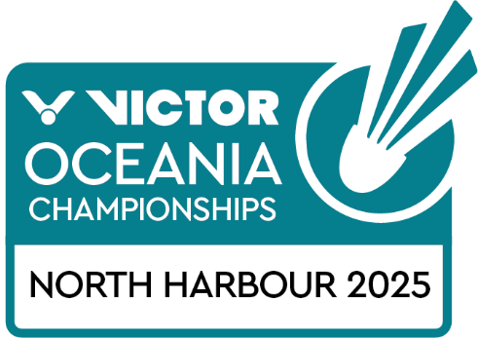
PRACTICE REQUEST FORM

Member Association Country:  Contact Phone Number:  Contact Name (full):  Contact Email address: | INSERT  INSERT  INSERT  INSERT
Booking Details | NUMBER OF PLAYERS PREFERRED TIME (9am – 2pm)  Wednesday 12 February  Available times: 9am – 2pm
Notes  Last date for submission | The organiser will allocate courts on a fair and equitable basis and will advise no later than 10 February 2025  These courts are for players who have not played in the Oceania Mixed Team Event  One request form per country.  This form will not be accepted from individual players it must be submitted by the Member Association or Team Manager  Please return this form by 31 January 2025 to:  events@badmintonoceania.org

