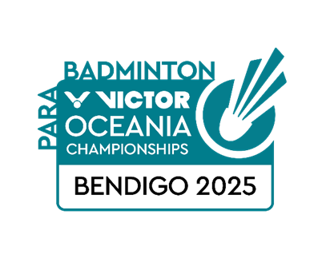**VICTOR OCEANIA PARA BADMINTON   
CHAMPIONSHIPS 2025**

**BENDIGO, AUSTRALIA**

**16-19 OCTOBER**

**PRACTICE REQUEST FORM**

|  |  |
| --- | --- |
| **Member Association Country:**  **Contact Phone Number:**  **Contact Name (full):**  **Contact Email address:** | INSERT  INSERT  INSERT  INSERT |
| **Booking Details** | |  |  |  |  | | --- | --- | --- | --- | | **DATE** | **No. WH Players** | **No. Standing Players** | **PREFERRED TIME** | | 15 October |  |  |  |   Practice courts available 10am – 6pm Wednesday 15 October |
| **Notes** | The organiser will allocate courts in the competition venue on a fair and equitable basis by 10 October 2025  Please return this form by Wednesday 1 October to:  Megan Bramley – [megan@badmintonoceania.org](mailto:megan@badmintonoceania.org) |