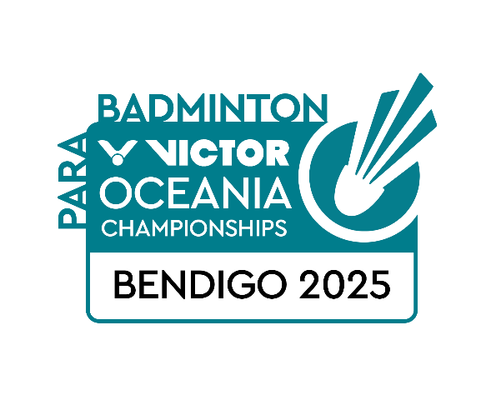**VICTOR OCEANIA PARA BADMINTON CHAMPIONSHIPS 2025  
BENDIGO, AUSTRALIA  
16-19 OCTOBER**

**VISA REQUEST FORM**

|  |  |
| --- | --- |
| **Member Association Country:**  **Contact Phone Number:**  **Contact Name (full):**  **Contact Email address:** | INSERT  INSERT  INSERT  INSERT |
| **Notes** | 1. Member associations requiring a Visa to enter Australia please complete the above form and return to:  Badminton Australia - [baevents2025@gmail.com](mailto:baevents2025@gmail.com) 2. For an invitation letter to cover both VICTOR Oceania Para Badminton Championships 2025 and Australian Para Badminton International 2025 please note ‘Yes’ or ‘No’ in each event column 3. We will forward the official invitation letter for your visa application to your contact email address the next business day after receipt 4. Please allow sufficient time for you visa application. We recommend applying at least 60 days prior to your planned travel |
| **Last date for submission** | Please return this form by **Wednesday 20 August 2025** |

|  |  |  |  |  |  |  |  |  |  |  |
| --- | --- | --- | --- | --- | --- | --- | --- | --- | --- | --- |
|  | **Family Name**  **(Passport)** | **Given Names**  **(Passport)** | **Gender** | **Nationality** | **Passport Number** | **Expiry Date** | **DOB** | **Role (player,**  **coach etc)** | **Tournaments Attending (Y/N)** | |
| **Oceania** | **Australia** |
| 1 |  |  |  |  |  |  |  |  |  |  |
| 2 |  |  |  |  |  |  |  |  |  |  |
| 3 |  |  |  |  |  |  |  |  |  |  |
| 4 |  |  |  |  |  |  |  |  |  |  |
| 5 |  |  |  |  |  |  |  |  |  |  |
| 6 |  |  |  |  |  |  |  |  |  |  |
| 7 |  |  |  |  |  |  |  |  |  |  |
| 8 |  |  |  |  |  |  |  |  |  |  |
| 9 |  |  |  |  |  |  |  |  |  |  |
| 10 |  |  |  |  |  |  |  |  |  |  |