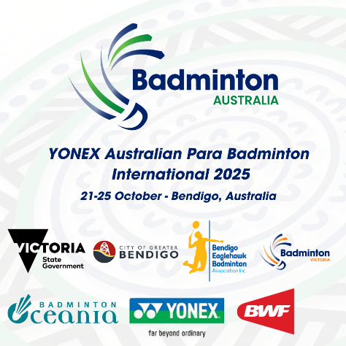**YONEX AUSTRALIAN PARA BADMINTON INTERNATIONAL 2025  
BENDIGO, AUSTRALIA  
21-25 OCTOBER**

**MEDIA REQUEST FORM**

|  |  |
| --- | --- |
| **Organisation:**  **Contact Name (full):**  **Contact Phone Number:**  **Contact Email address:** | INSERT  INSERT  INSERT  INSERT |
| **Notes** | 1. All media personal to complete this form and return to:  Julie Carrel – [julie@badmintonoceania.org](mailto:julie@badmintonoceania.org) 2. Media to follow directions of tournament staff at all times |
| **Last date for submission** | Please return this form by **Friday 12 September 2025** |