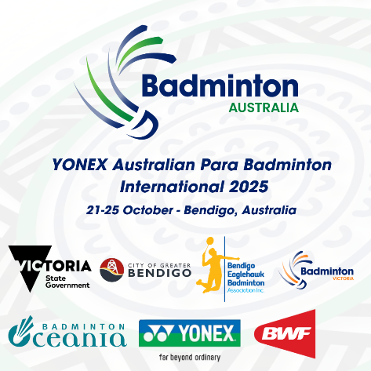**YONEX AUSTRALIAN PARA BADMINTON  
 INTERNATIONAL 2025**

**BENDIGO, AUSTRALIA**

**21-25 OCTOBER**

**PRACTICE REQUEST FORM**

|  |  |
| --- | --- |
| **Member Association Country:**  **Contact Phone Number:**  **Contact Name (full):**  **Contact Email address:** | INSERT  INSERT  INSERT  INSERT |
| **Booking Details** | |  |  |  |  | | --- | --- | --- | --- | | **DATE** | **No. WH Players** | **No. Standing Players** | **PREFERRED TIME** | | Sunday 19 October |  |  |  | | Monday 20 October |  |  |  |   Practice courts available 5pm – 8pm Sunday 19 October  Competition courts avaliable 10am – 6pm Monday 20 October |
| **Notes** | The organiser will allocate courts in the competition venue on a fair and equitable basis by 17 October 2025  Please return this form by Wednesday 8 October to:  Julie Carrel – julie@badmintonoceania.org |