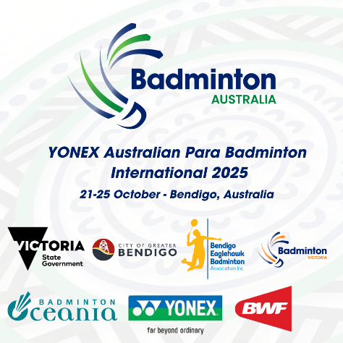**YONEX AUSTRALIAN PARA BADMINTON INTERNATIONAL 2025  
BENDIGO, AUSTRALIA  
21-25 OCTOBER**

**VISA REQUEST FORM**

|  |  |
| --- | --- |
| **Member Association Country:**  **Contact Phone Number:**  **Contact Name (full):**  **Contact Email address:** | INSERT  INSERT  INSERT  INSERT |
| **Notes** | 1. Member associations requiring a Visa to enter Australia please complete the above form and return to:  Badminton Australia - [baevents2025@gmail.com](mailto:baevents2025@gmail.com) 2. We will forward the official invitation letter for your visa application to your contact email address the next business day after receipt 3. Please allow sufficient time for you visa application. We recommend applying at least 60 days prior to your planned travel |
| **Last date for submission** | Please return this form by **Wednesday 27 August 2025** |

|  |  |  |  |  |  |  |  |  |
| --- | --- | --- | --- | --- | --- | --- | --- | --- |
|  | **Family Name**  **(Passport)** | **Given Names**  **(Passport)** | **Gender** | **Nationality** | **Passport Number** | **Expiry Date** | **DOB** | **Role (player,**  **coach etc)** |
|
| 1 |  |  |  |  |  |  |  |  |
| 2 |  |  |  |  |  |  |  |  |
| 3 |  |  |  |  |  |  |  |  |
| 4 |  |  |  |  |  |  |  |  |
| 5 |  |  |  |  |  |  |  |  |
| 6 |  |  |  |  |  |  |  |  |
| 7 |  |  |  |  |  |  |  |  |
| 8 |  |  |  |  |  |  |  |  |
| 9 |  |  |  |  |  |  |  |  |
| 10 |  |  |  |  |  |  |  |  |