YONEX Bendigo International 2025
BENDIGO, VICTORIA, AUSTRALIA
15 – 19 October 2025

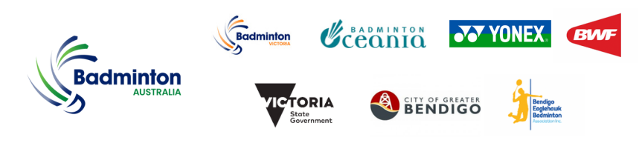
PRACTICE REQUEST FORM
Member Association Country:  Contact Phone Number:  Contact Name (full):  Contact Email address: | INSERT  INSERT  INSERT  INSERT
Booking Details | Practice courts are located at:  Bendigo-Eaglehawk Badminton Association  140 Victoria Street, Eaglehawk  Please complete the practice request table below. Courts are available Mon 13th Oct 10:00am - 6:00pm and Tue 14th Oct 9:00am - 07.00pm  DATE NUMBER OF PLAYERS PREFERRED TIME  Mon 13th Oct 2025  Tue 14th Oct 2025  The organiser will allocate the practice/competition courts for Tuesday based on the number of players, arrival times and court availability on a fair and equitable basis.  Practice requests confirmation for Wed 15th onwards will be notified at the venue upon approval by the Referee.
Return form to | Please complete and return this form by Friday 3rd October 2025 to:  Name: Anthony Pinda  Email: baevents2025@gmail.com

