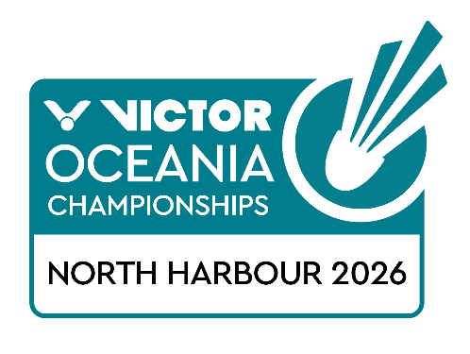
PRACTICE REQUEST FORM

Member Association Country:  Contact Phone Number:  Contact Name (full):  Contact Email address: | INSERT  INSERT  INSERT  INSERT
Booking Details | Available times: 9am – 8pm
   | NUMBER OF PLAYERS | PREFERRED TIME  (9am – 8pm)
  Saturday 7 February
Notes  Last date for submission | The organiser will allocate courts on a fair and equitable basis and will advise no later than Thursday 5 February 2026  One request form per country.  This form will not be accepted from individual players it must be submitted by the Member Association or Team Manager  Please return this form by 19 January 2026 to:  events@badmintonoceania.org

