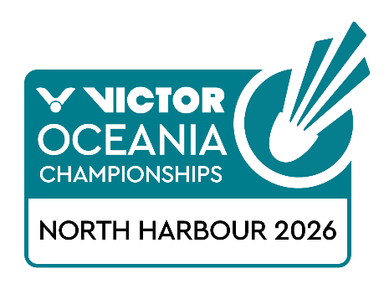
TRANSPORT REQUEST FORM
VICTOR Oceania Championships 2026
Member Association Country  Contact Phone number  Contact name (full)  Contact email address | INSERT  INSERT  INSERT  INSERT
Group 1
  GROUP 1 | ARRIVAL DETAILS | DEPARTURE DETAILS
  DAY/DATE/TIME:
  FLIGHT NUMBER:
  TOTAL NO: OF PERSONS:
  ACCOMMODATION:
  GROUP LEADER (NAME & MOBILE)
Group 2
  GROUP 2 | ARRIVAL | DEPARTURE
  DAY/DATE/TIME:
  FLIGHT NUMBER:
  TOTAL NO: OF PERSONS:
  ACCOMMODATION:
  GROUP LEADER (NAME & MOBILE)
Notes | - Transport is for arrivals & departures at Auckland International Airport.  - Transport will only be provided on 6th, 7th, 12th & 13th (individuals), 15th & 16th (teams) February 2026 unless otherwise agreed with BOC  - Transport is only provided to teams/players staying at the official accommodation providers  - Please notify organiser if details change prior to arrival.  - This form will not be accepted from individual players, it must be submitted by the Member Association or the Team Manager
Last date for submission | Please return this form by 19 January 2026 to:  events@badmintonoceania.org

