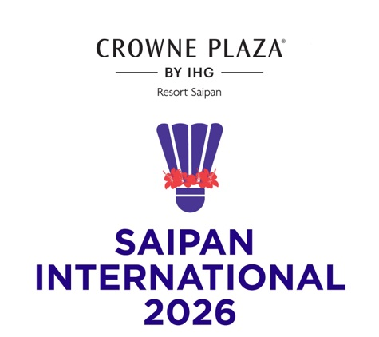
CROWNE PLAZA
Saipan International 2026
21 – 25 July 2026

PRACTICE REQUEST FORM

MEMBER ASSOCIATION Country: |  | CONTACT NAME In full:
CONTACT NUMBER |  | CONTACT Email address:

DATE | NUMBER OF PLAYERS | Practice Courts (6) |  | Competition Courts (4)
DATE | NUMBER OF PLAYERS | Available  Time | Request  Time | Available  Time | Request Time
Sun 19 July |  | 9am – 5pm |  | Not Available
Mon 20 July |  | 9am – 5pm |  | 9am - 5pm
Tue 21 July |  | 9am – 5pm | To book after TM Meeting | Not Available
Wed 22 July |  | 9am – 5pm | To book on Tuesday | Not Available
Thu 23 July |  | 9am – 5pm | To book on Wednesday | Not Available
Fri 24 July |  | 9am – 5pm | To book on Thursday | Not Available
Sat 25 July |  | 9am – 5pm | To book on Friday | Not Available

Notes:
1. There are three (3) competition courts and one (1) warm up court at the Gilbert C. Ada Gymnasium.
2. There are six (6) practice courts at the Marianas High School Gymnasium.
3. Based on information provided above by all participants, the event organiser will arrange
a fair practice session times for all competitors.
4. Courts will be available for practice starting on Sunday 19 July.

Please return this form by Friday 10 July 2026 for bookings on Sunday and Monday to:
Event Director
Email: roselynmonroyo@gmail.com Telephone: 1-670-789-1845

