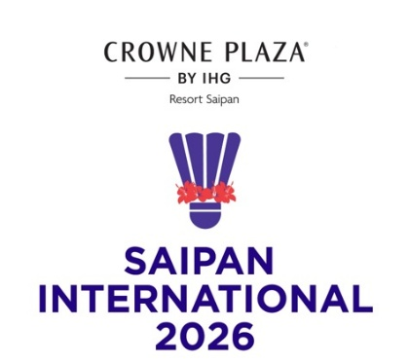
CROWNE PLAZA Saipan International 2026
SAIPAN, NORTHERN MARIANA ISLANDS
21 – 25 July 2026

TRANSPORT REQUEST FORM

MEMBER ASSOCIATION Country: |  | CONTACT NAME In full:
CONTACT Phone number: |  | CONTACT Email address:

GROUP 1 | ARRIVAL | DEPARTURE
DAY/DATE/TIME:
FLIGHT NUMBER:
TOTAL NO: OF PERSONS:
GROUP LEADER (NAME & WHATS APP NUMBER)

GROUP 2 | ARRIVAL | DEPARTURE
DAY/DATE/TIME:
FLIGHT NUMBER:
TOTAL NO: OF PERSONS:
GROUP LEADER (NAME & WHATS APP NUMBER)

Notes:
If you are playing the YONEX Northern Marianas Open 2026 as well as this tournament you only need to submit one transport form, due Friday 3 July 2026

1. Transport pick up available for participants arriving at the Saipan International Airport
2. Transport is provided ONLY for participants staying at the official accommodations (Crowne Plaza Resort Saipan).
3. Please notify organiser if above flights details have changed prior to arrival.

Please return this form by Friday 10 July 2026 to:
Please return this form to: Event Director - Roselyn Monroyo
Email: roselynmonroyo@gmail.com

If this form is not received by 10 July, airport transfers cannot be provided

