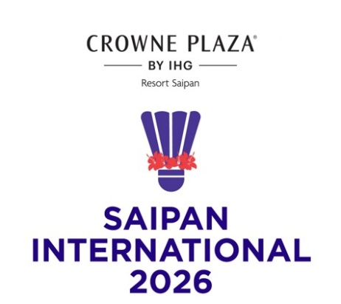
CROWNE PLAZA
Saipan International 2026
SAIPAN, NORTHERN MARIANA ISLANDS
21-25 July 2026

VISA LETTER REQUEST FORM

MEMBER ASSOCIATION Country: |  | CONTACT NAME In full:
CONTACT Phone number: |  | CONTACT Email address:

NO | FAMILY  NAME  (passport) | GIVEN  NAMES  (passport) | GENDER | NATIONALITY | PASSPORT NUMBER | EXPIRY DATE | DATE OF BIRTH | ROLE (player, coach, etc)
1
2
3
4
5
6
7
8
9
10
Notes:
If you are playing the YONEX Northern Marianas Open 2026 as well as this tournament you only need to submit one form
- Players and officials requiring a Visa support letter to enter the NMI must complete the above form and return to Event Director as soon as possible.
- To see list of countries under the United States and NMI Visa Waiver Program and who would only need Electronic System for Travel Authorization (ESTA), visit https://www.dhs.gov/visa-waiver-program-requirements or https://esta-center.com/en/guam/index.html for more information.
- The Official invitation letter for your Visa application will be sent to your contact address.
- Please allow sufficient time for the processing of your application. We recommend applying at least 45 days prior to your planned travel dates.

Please return this form to:
Event Director – Roselyn Monroyo Email: roselynmonroyo@gmail.com

