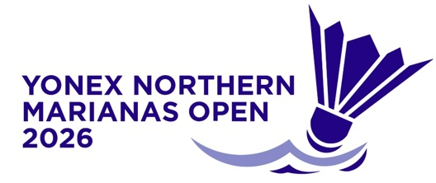
YONEX Northern Marianas
Open 2026
Saipan, Northern Mariana Islands
14 – 19 July 2026

ACCREDITATION FORM

*ATTACH THE FOLLOWING: 2x2” photo (No hats/caps or glasses/sunglasses)

Personal Information
Complete Name:
Country: |  | Role/Position:
Email:
Deadline: Tuesday 7 July 2026
Submit Form to Accreditation Committee member Khristelle Itaas at khristelle_itaas@tanholdings.com
And copy in Roselyn Monroyo roselynmonroyo@gmail.com

