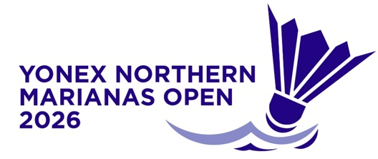
YONEX Northern Marianas
Open 2026
Saipan, Northern Mariana Islands
14 – 19 July 2026

PRACTICE REQUEST FORM

MEMBER ASSOCIATION Country: |  | CONTACT NAME In full:
CONTACT NUMBER |  | CONTACT Email address:

DATE | NUMBER OF PLAYERS | Practice Courts (6) |  | Competition Courts (4)
DATE | NUMBER OF PLAYERS | Available  Time | Request  Time | Available  Time | Request Time
Sun 12 July |  | 9am – 5pm
Mon 13 July |  | 9am – 5pm |  | 9am-7pm
Tue 14 July |  | 9am – 5pm | To book after TM Meeting | Not Available
Wed 15 July |  | 9am – 5pm | To book on Tuesday | Not Available
Thu 16 July |  | 9am – 5pm | To book on Wed | Not Available
Fri 17 July |  | 9am – 5pm | To book on Thurs | 9am – 1pm | To book on Thurs
Sat 18 July |  | 9am – 5pm | To book on Fri | 9am – 1pm | To book on Fri
Sun 19 July |  | 9am – 5pm | To book on Sat | Not Available

Notes:
1. There are three (3) competition courts and one (1) warm up court at the Gilbert C. Ada Gymnasium.
2. There are six (6) practice courts at the Marianas High School Gymnasium.
3. Based on information provided above by all participants, the event organiser will arrange
a fair practice session times for all competitors.
4. Courts will be available for practice starting on Sunday, 12 July 2026.
5. Bookings on the competition courts on Friday, 17 and Saturday, 18 July will only be available for players remaining in the tournament.

Please return this form by Friday, 3 July 2026 for bookings on Sunday and Monday to:
Event Director – Roselyn Monroyo
Email: roselynmonroyo@gmail.com Telephone: 1-670-789-1845

