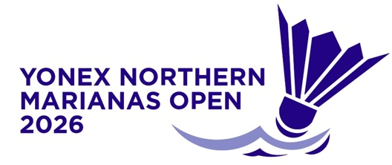
YONEX Northern Marianas
Open 2026
Saipan, Northern Mariana Islands
14 – 19 July 2026

TRANSPORT REQUEST FORM

MEMBER ASSOCIATION Country: |  | CONTACT NAME In full:
CONTACT Phone number: |  | CONTACT Email address:

GROUP 1 | ARRIVAL | DEPARTURE
DAY/DATE/TIME:
FLIGHT NUMBER:
TOTAL NO OF PERSONS:
GROUP LEADER (NAME & WHATS APP NUMBER)

GROUP 2 | ARRIVAL | DEPARTURE
DAY/DATE/TIME:
FLIGHT NUMBER:
TOTAL NO OF PERSONS:
GROUP LEADER (NAME & WHATS APP NUMBER)

Notes:
1. Transport pick up available for participants arriving at the Saipan International Airport
2. Transport is provided ONLY for participants staying at the official accommodations (Crowne Plaza Resort Saipan).
3. Please notify organiser if above flights details have changed prior to arrival.

Please return this form by Friday 3 July 2026 to:
Event Director - Roselyn Monroyo
Email: roselynmonroyo@gmail.com

If this form is not received by 3 July, airport transfers cannot be provided



