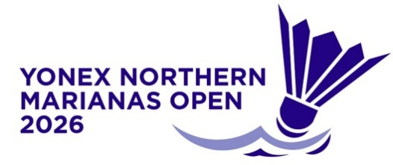
YONEX Northern Marianas Open, 14 – 19 July 2026
VISA LETTER REQUEST FORM

MEMBER ASSOCIATION Country: |  | CONTACT NAME In full:
CONTACT Phone number: |  | CONTACT Email address:

NO | FAMILY NAME  (passport) | GIVEN NAMES  (passport) | GENDER | NATIONALITY | PASSPORT NUMBER | EXPIRY DATE | DATE OF BIRTH | ROLE (player, coach, etc)
1
2
3
4
5
6
7
8
9
10

Notes:
- Players and officials requiring a Visa support letter to enter the NMI must complete the above form and return to Event Director as soon as possible.
- To see list of countries under the United States and NMI Visa Waiver Program and who would only need Electronic System for Travel Authorization (ESTA), visit https://www.dhs.gov/visa-waiver-program-requirements or https://esta-center.com/en/guam/index.html for more information.
- The official invitation letter for your Visa application will be sent to your contact address
- Please allow sufficient time for the processing of your application. We recommend applying at least 45 days prior to your planned travel dates.

Please return this form to: Event Director – Roselyn Monroyo Email: roselynmonroyo@gmail.com

